**Perform Basic Visualizations for all the columns(numerical data only) on any**

**data set from data set folder make sure it has more data. So we can make better inferences for the visualizations(boxplot,histogram)**

**We have computer data which as the** observation of the 6259

price variable:

Histogram

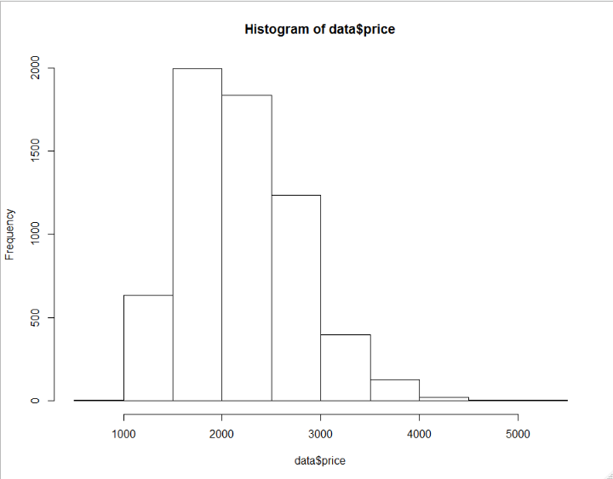

* This variable is following right skewed and not normal distribution
* The mode is from the 1500 to 2000
* The prices of the computer mostly ranges from 1500-2500
* There are less computer prices more then 3000

**Boxplot**

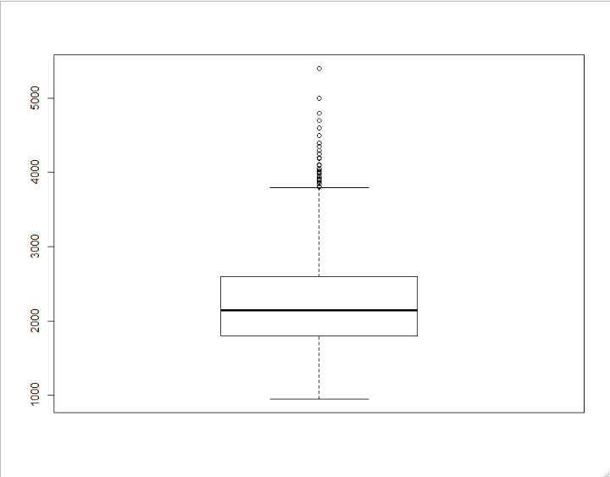

* **We can observe some outliers in this variable price**
* **The data set variable is right skewed**
* **We can see most of data is in between 1500-2500 which is our inter quartile range**

**Speed variable**

**Histogram:**

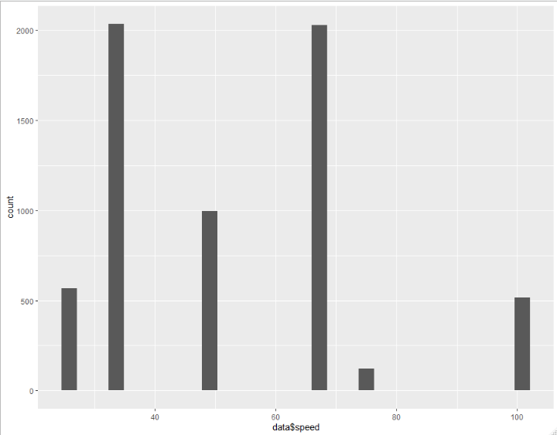

* **This is not following normal distribution**
* **There are two giant leaps on 25 and 50**
* **Most of the computer have speed 25 or 50**

**Boxplot:**

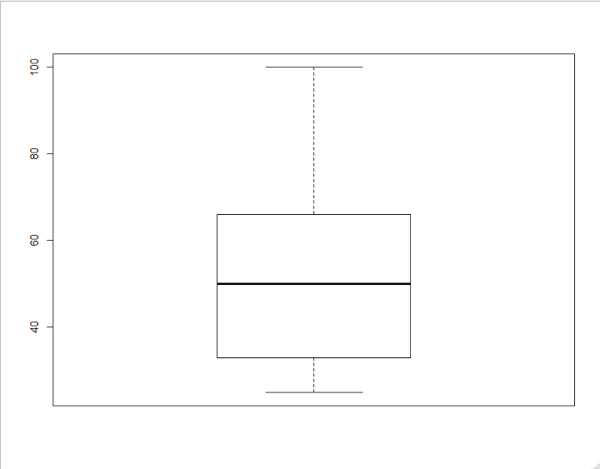

* **There are no outliers**
* **The distribution of the data point is mostly rightly skewed**

**Hd Variable**

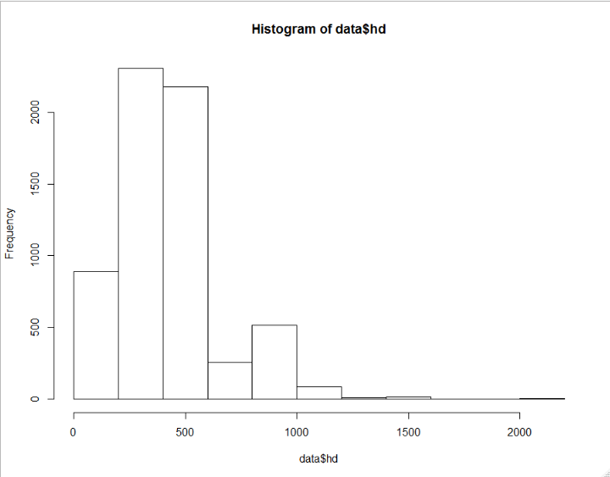

* **The data points are right skewed**
* **Most of the data points lie below the 500**

**Boxplot**

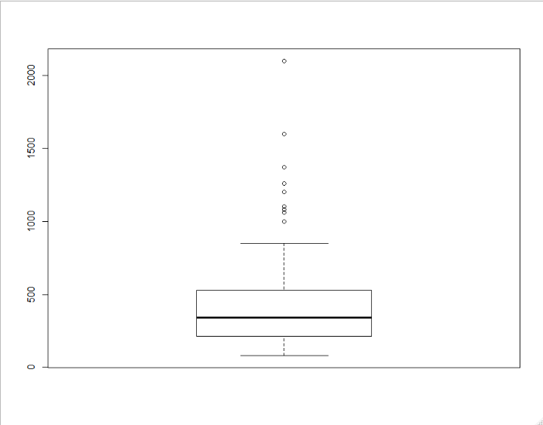

* **There are outliers in the data set**
* **Most of the data points lies below the 500**

**Ram variable:**

**Histogram**

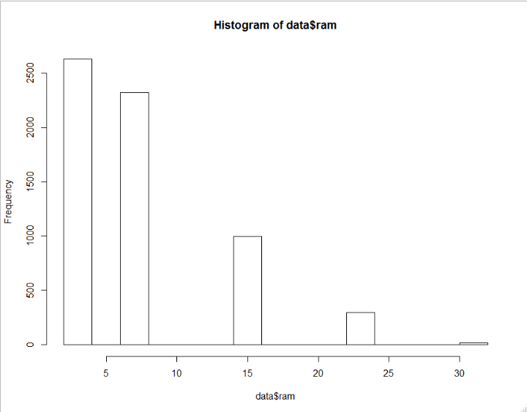

* **The distribution is right skewed**
* **Most of the data points lies below 10**
* **There are less computer with ram more than 10**
* **Most of the computer available are having less than 10ram**

**Boxplot**

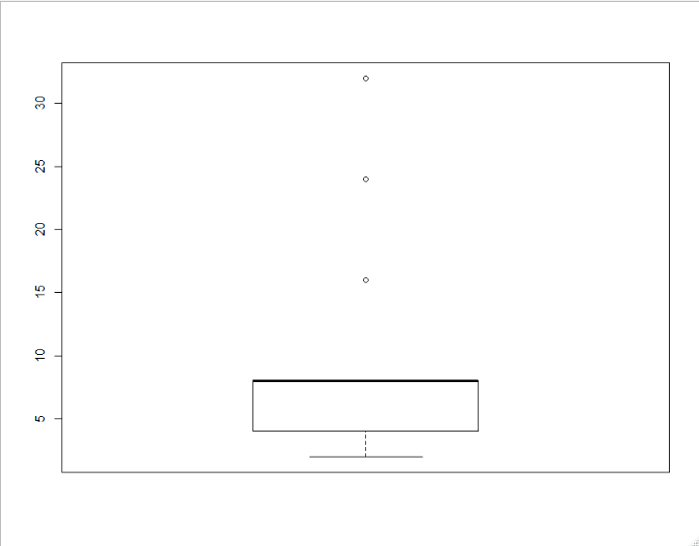

* **Here we can see the Q2 and Q3 have been overlapped there no right tail so more than 50% data points lie below the 10**
* **There are some outliers**

**Screen variable**

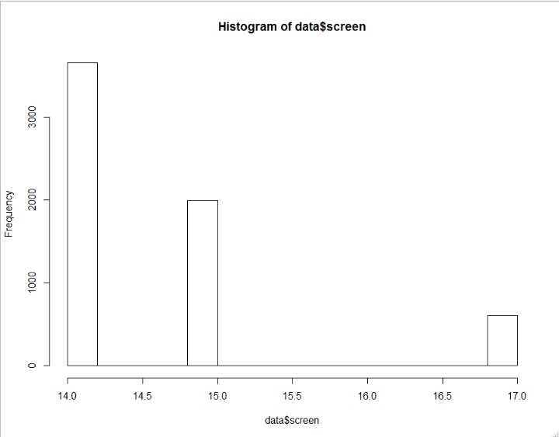

* **Most of the data point are on 14 and 15**
* **Most of computer are with screen size14-15**
* **Right skewed**

**Boxplot**

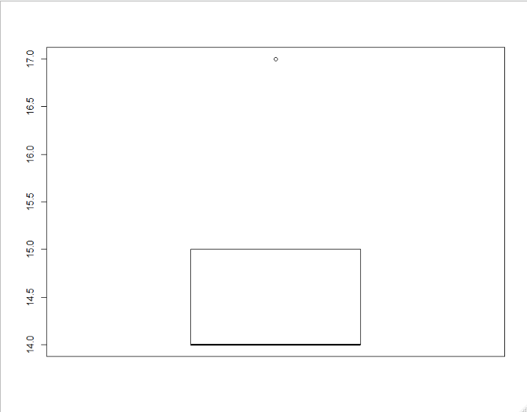

* **Here we see that there are no tails in the distribution**
* **Most of the data points lie in 14 and 15**
* **One outlier i.e is 17**